UML Class Diagram

|  |
| --- |
| **BlueDrum** |
| -drumsound: QMediaPlayer* |
| <<constructor>>+BlueDrum()  +keyPressEvent(event: QkeyEvent*)  +move() |

|  |
| --- |
| **Button** |
| -text: QGraphicsTextItem* |
| <<constructor>>+Button(name: QString, parent: QGraphicsItem*)  +mousePressEvent(event: QGraphicsSceneMouseEvent*)  +hoverEnterEvent(event: QGraphicsSceneHoverEvent*)  +hoverLeaveEvent(event: QGraphicsSceneHoverEvent*) |

|  |
| --- |
| **Game** |
| +startscene: QGraphicsScene*  +player: Player*  +score: Score*  +time: Time* |
| <<constructor>>+Game(parent: QWidget*)  +displayMainMenu()  +gameOver()  +displayGameOverWindow()  +countdown()  +start()  +restartGame()  -drawPanel(x: Integer, y: Integer, width: Integer, height: Integer, color: QColor, opacity: Double) |

|  |
| --- |
| **Player** |
|  |
| <<constructor>>+Player(parent: QGraphicsItem*)  +spawn() |

|  |
| --- |
| **RedDrum** |
| -drumsound: QMediaPlayer* |
| <<constructor>>+RedDrum()  +keyPressEvent(event: QkeyEvent*)  +move() |

|  |
| --- |
| **Runner** |
|  |
| <<constructor>>+Runner()  +move() |

|  |
| --- |
| **Score** |
| -score: Integer |
| <<constructor>>+Score(parent: QGraphicsItem*)  +increase()  +getScore(): Integer |

|  |
| --- |
| **Time** |
| -time: Integer |
| <<constructor>>+Time(parent: QGraphicsItem*)  +decrease()  +getTime(): Integer |

Screen Shot



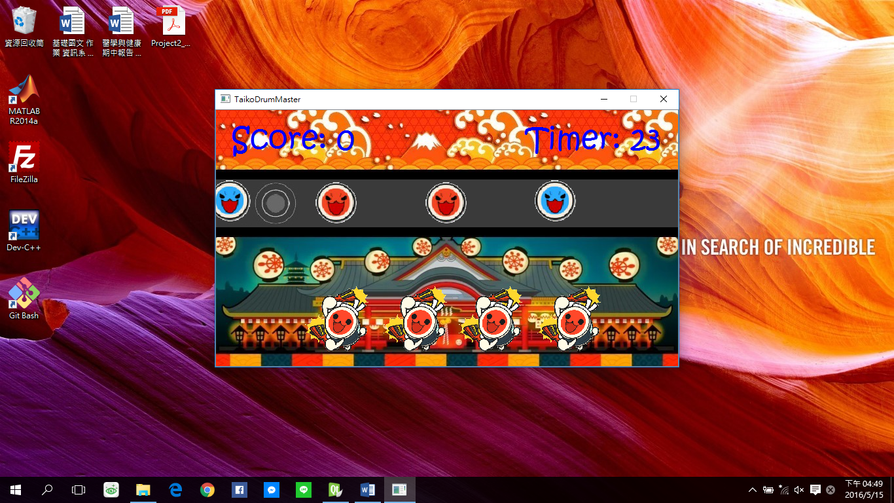

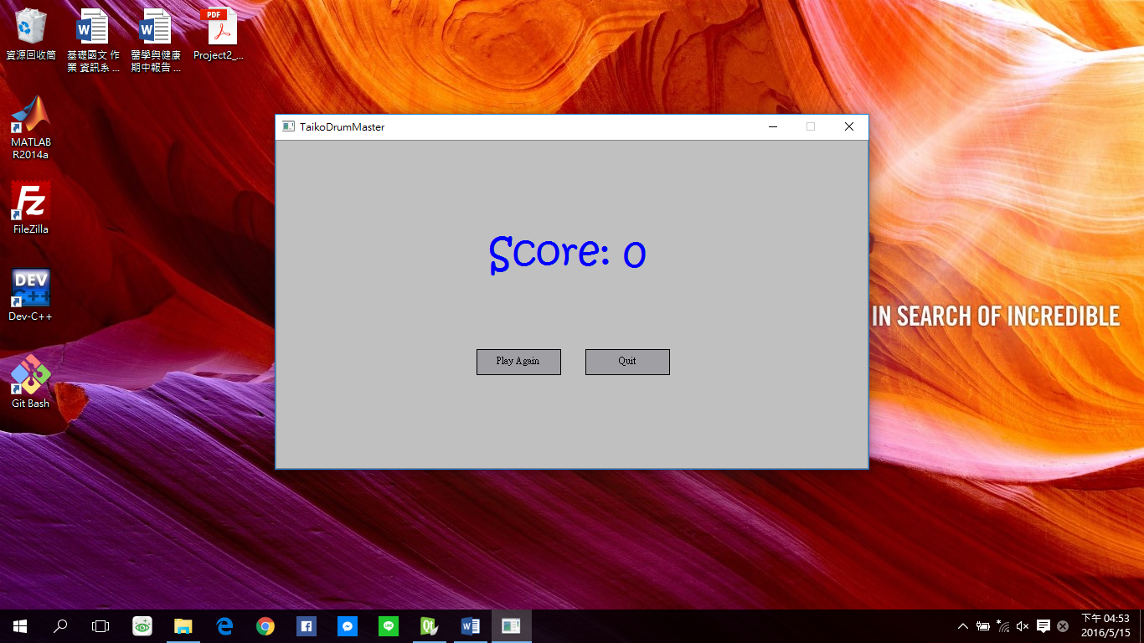

How To Play

Press F key to eliminate the blue drum and press J key to eliminate the red drum.

Program Architecture

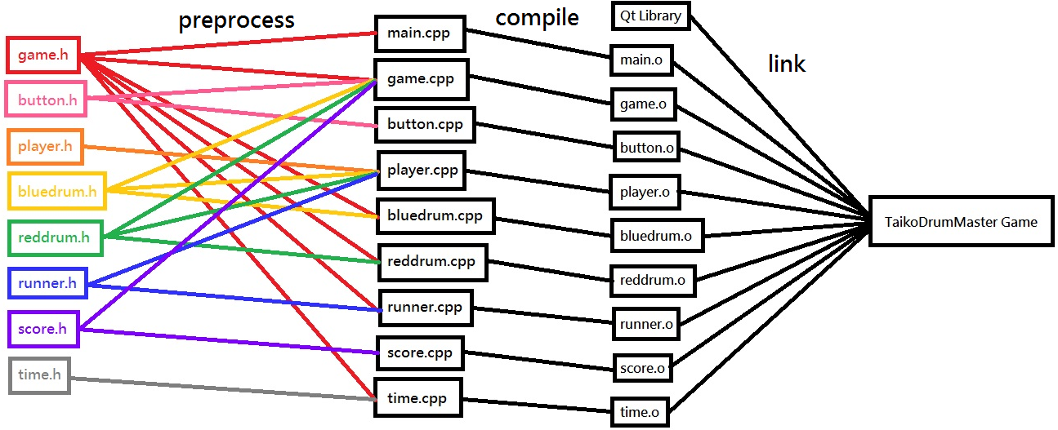

Bonus

1. Backgound music
2. Sound effect when drums move into the target region and the keys are pressed
3. Buttons change color when the cursor hovers over them
4. Running drum pictures on the bottom of the window when the game executes